

Capstone Project Phase B

Project 21-2-R-13

Department of Software Engineering

Braude College of Engineering, Israel

**Authorship Analysis**

**Using Impostors Method**

In partial fulfillment of the requirements for

Capstone Project in Software Engineering (61999)

Karmiel – January 2022

|  |  |  |
| --- | --- | --- |
| Raz Itzhak Afriat | 208220418 | raz.itzhak.afriat@e.braude.ac.il |
| Konstantin Maltcev | 336492640 | konstantin.malcev@e.braude.ac.il |

Supervisors:

Dr. Renata Avros

Prof. Vladimir (Zeev) Volkovich

**Contents**

Abstract 3

1. Introduction 3

2. Background and Related Work 4

2.1. Natural Language Processing 4

2.2. Neural Networks 4

2.3. Convolutional Neural Network 5

2.4. Recurrent Neural Network 5

2.5. Long Short-Term Memory 5

2.6. Word Embedding 5

2.7. ELMo embedding 5

2.8. ReLU activation function 6

2.9. Natural Language Toolkit 6

2.10. Dynamic Time Wrapping Distance 6

2.11. Related Work 6

3. Achievements 7

3.1. Plagiarism detection system based on Impostors Method & CNN/BLSTM 7

3.2. Graphical User Interface (GUI) 8

4. Research Process 8

4.1. Process 8

4.2. Product 9

4.2.1. Data preprocessing and embedding 10

4.2.2. Data similarity measurements 10

4.2.3. CNN 11

4.3. Bi-LSTM 12

4.4. Network Parameters 13

4.4.1. CNN Component default parameters: 13

4.4.2. Bi-LSTM Component default parameters 13

4.5. Graphical User Interface 14

5. Evaluation and Verification Plan 15

6. Appendices 16

6.1. User Guide 16

6.2. Maintenance Guide 18

6.2.1. Class Diagram 18

6.2.2. Environment Description 18

References 19

# Abstract

The plagiarism event is occurring since early days and is very hard to prove. Thanks to advanced technological systems, detecting such acts is now possible. The novelist Mikhail Aleksandrovich Sholokhov was accused of plagiarism countless times for his work ‘And Quiet Flows the Don’. Attempts to determine if he is the real author from a mathematical standpoint supported him eventually. For many interested parties, it is important to make sure that these sorts of crimes will be revealed.

This paper proposes a solution for the Authorship Analysis problem and plagiarism detection based on the “Impostors’ method” algorithm alongside the use of a CNN-LSTM model. The solution takes the “Tweets Approach” and dividing the input text into small chunks to recognize short patterns in it. With the aim to prove the ability of detecting the plagiarism crime with impostors’ method, we have built a system alongside a GUI to operate it based on these models. The systems’ initial parameters are set and can change via the GUI to find the best combination of parameters and improve accuracy. The program is evaluated using Sholokhov literature and other authors works during the test phase. While these tests are being performed, the system’s behavior is compared with expected behaviors. The expected behaviors are predefined in test cases from a designed test plan.

**Keywords:** cnn; lstm; authorship analysis; impostors’ method; natural language process.

# Introduction

Plagiarism is defined as the practice of taking someone else’s work or ideas and passing them off as one’s own. In early times it was extremely hard if not impossible to detect such a crime, but recently, with the technological advancement and the usage of sophisticated systems, it is possible to produce a favorable evaluation. Without using modern technology, one cannot, in most cases, prove plagiarism. That is because overlapping words are not enough proof by themselves. Often, it is impossible to find sufficient evidence for the claim of authorship. As a form of theft, steps to stop and reveal plagiarism are important and should be taken.

A variety of parties are interested in the development of an accurate system of Authorship Analysis. Victims are eager to prove their claims, lawyers, and all the judgment systems involved with plagiarism. Readers want to know the actual author of their beloved literature to know whom they should follow, admire, etc. Publishers and investors want to know the true artists so they can make suitable investments.

Mikhail Aleksandrovich Sholokhov was a Russian novelist who had won a Nobel Prize in Literature in 1965. ‘And Quiet Flows the Don’ is an epic novel by Sholokhov, considered among his most significant works. For this creation, Sholokhov was accused of plagiarism repeatedly under many different claims. Moscow State University’s research in 2020 claimed that ‘And Quiet Flows the Don’ indeed belongs to Sholokhov. Their claims are backed up with graphical results of a text distance measure algorithm called Burrow’s Delta. Other approaches and attempts to solve this matter were taken and supported Sholokhov.

Simply put, Tweets are messages sent on Twitter. In reference, the term Tweet is used to describe any short text, usually limited to a fixed size and straightforward, most often in the field of social networks. Tweet analysis is now a big trend in Natural Language Processing due to the need to detect malicious bots’ emails and analyze the huge amount of data from Facebook, Twitter, etc. It is dividing a document into tweets that yields more significant results in the field of sentiment analysis since it enables the analysis of a widely changing document. For instance, in the case of having many external quotations of text that do not belong to the author, the small chunks of the author’s writing make all the difference.

The impostors’ method is a widely used Machine Learning (ML) supervised classifier that excels in authorship verification tasks. The system is learning to distinguish between a collection of one author’s work, and a collection of another author’s literature, using a two-class classifier. After that, a test is applied with the questionable literature alongside genuine works of the accused author, and the behavior of it is being observed under the assumption that if the piece is indeed the author’s work, it should be classified the same as his other works. The project’s agenda is to improve an existing model implementation of the algorithm based on Convolutional Neural Network (CNN) with the Long Short-Term Memory (LSTM) model. To improve the predictions efficiency, a Dynamic Time Wrapping distance is applied to ensure that the provided texts are somewhat similar.

# Background and Related Work

## Natural Language Processing

NLP is a subfield of artificial intelligence focused on studying the interaction between human languages and computer systems. Due to the persuasion of the development of systems capable of “understanding” human documents, many algorithms are now widespread in NLP, for example, Keyword Extraction algorithms, sentiment analysis algorithms, etc.

## Neural Networks

Neural Networks are types of Machine Learning (ML) algorithms developed with inspiration from the human brain’s neural network. A neural network’s model can learn and analyze huge amounts of data, making it possible to detect patterns in it and accomplish other different tasks as well. These days neural networks are extremely popular and are applied in most ML problems’ solutions.

## Convolutional Neural Network

Convolutional Neural Networks are a commonly used type of neural network. Their model originated from a study of the human brain's cortex in the 1980s. They use the convolution function and have three main types of layers. The convolutional layer requires the input data, a filter, a feature map and is responsible for most of the computational work. The pulling layer, or downsampling, conducts dimensionality reduction and reduces the input’s number of parameters. Lastly, the Fully Connected layer is responsible for the classification tasks.

## Recurrent Neural Network

Recurrent Neural Network is another type of neural network in which the output of a stage is processed as input for the step after it. However, sometimes it is required to output a “forecast” based on input, for instance, when one wants to predict the next word based on previous words in sentences. RNN is solving this task, using a unique layer named “Hidden” and thus, the heart of RNN is the ability to have the hidden state, which remembers information of the previous states.

## Long Short-Term Memory

Long Short-Term Memory Networks is a kind of Recurrent Neural Network only that LSTM is capable of memorizing states for the long term. For example, it is common to predict current output; the information processed and stored a long time ago is required. Though, RNN is incapable of maintaining and reaching these long-term dependencies and thus fails these sorts of tasks. When using LSTM, it is not required to store a finite number of beforehand states. Architecturally, LSTM is extending the RNN hidden layer to four different layers interacting with each other, producing as output the layer’s output alongside its state, making it possible to maintain such a memory.

## Word Embedding

Word Embedding is a method of bridging between humans’ representation of languages and computers. In an N-dimensional space, the method holds representations for texts in a way that one representation should be close to another if the words' meanings are similar. It is based on mathematics and the ability to produce good numerical representations, which computers can comprehend with. These vectors of word representations are crucial for solving almost any of the natural language processing tasks.

## ELMo embedding

ELMo is an NLP framework developed by AllenNLP. They are implementing a novel way of embedding words and representing them in vectors. It handles complex characteristics of words and, as well, the way these words’ uses are varied. ELMo is achieving excellent results in several NLP tasks and is now widely used by researchers and the industry.

## ReLU activation function

The Rectified Linear Unit is the most used activation function in deep learning models. It returns the value of its input, or zero if the input was negative. Even though it is simple and only composed of two linear pieces, the ReLU function works great in most applications and is widely used. Among the ReLU advantages is its computational cheapness, the absence of the vanishing gradient problem, which many other activation functions are suffering from. ReLU is also natural and intuitive because it is sparsely activated, mimicking the biological neural network better.

## Natural Language Toolkit

Natural Language Toolkit is a platform used for building any kind of product in statistical natural language processing (NLP). It contains text processing libraries for tokenization, parsing, classification, stemming, tagging, and semantic reasoning. It also includes graphical demonstrations and sample data sets, and a cookbook that explains the principles behind the underlying language processing tasks.

## Dynamic Time Wrapping Distance

Being able to meaningfully define similarities between data objects is vital. One famous approach for defining is the Dynamic Time Warping distance. The basic idea is to find a non-linear matching of the points of two time series which is equivalent to stretching or compressing the time series in the x-axis. The result is a distance measure which captures the human perception of similarity better than the classic Euclidean distance. One can derive artificial time series by counting the occurrences of relevant keywords in a sliding window applied to them.

## Related Work

Plagiarism detection is considered a Natural Language Processing task, and therefore, most of the proposed solutions for syntactic or lexical plagiarism are of “concept extraction” using a corpus. NLP and its subtasks are hot trends in research and the industry as well. Authorship Analysis is closely linked to other fields of NLP, such as authorship attribution and sentiment analysis. This section is a review of a few of the attempts made to solve these tasks.

As mentioned above, to achieve greater results when solving NLP tasks, it is best to choose and use the fittest embedding method. It is not a simple task, especially where resources of the specific task are few. For instance, [3] proposed a model for sentiment analysis of Arabic tweets even though, relatively, there are not enough available resources like tools or research on the specific challenges of the language in the field of NLP. [3] used the AraVec word embedding and an ensemble model of CNN and LSTM, to predict the sentiment of the tweets. [3]s outstanding approach is applied. For the activation function, ReLU was chosen at the fully connected layer, just before a dropout and SoftMax output layers.

A paper by Z. Volkovich (2020) [2] presents a novel approach to solve the task of the General Authorship Attribution problem and investigates medieval Arabic documents. [2] produced evaluations regarding two manuscripts, questionably attributed to the famous Islamic jurist, theologian, and mystical thinker Abu Hamid Al Ghazali. Taking the “Tweets Approach”, he divided the documents into tweets and analyzed them. The division into tweets is important when “The devil is in the details'', meaning that the general characteristic of the document may not be close to the author’s writing style, but there are few points in the texts that add the author’s “touch”. Medieval writings require this approach the most since it is full of external quotations and texts that do not belong to the writer.

[7] Used and tested the Impostors Method to classify blog pairs and assign them either to “Belongs to author” or “Does not belong to the author”. Tests are conducted to evaluate performance with different algorithms and different ways of choosing input impostors. Among the other insightful findings, [7] shows that best results are yielded when using the impostors' method and especially when picking impostors with relatively similar writings.

# Achievements

## Plagiarism detection system based on Impostors Method & CNN/BLSTM

A system, alongside an operational GUI, that can now detect and analyze plagiarisms, based on the iterative Impostors Method is built and operational. The system receives as inputs a list of pairs of authors alongside their creations. After receiving the inputs, the algorithm is running and learns how to classify texts into the authors. With the ability to tweak its parameters, great results were shown in tests - Plagiarized creations are being detected as anomalies while innocence authors earned their credits.

First, the system is properly preprocessing and creates embeddings for each chunk of the input text. It later applies DTW distance measures techniques to assist the researcher find the best combinations of impostors’ authors. The chunks are fed to CNN and LSTM models and yields great results in the classification tasks. Tests are applied with all the author-under-test books and with its questionable creation. Distribution of chunks of the creations are displayed for them and is ready to be analyzed by the researcher. Using a threshold, the system predicts if the work is genuine. The algorithm is being ran multiple times to ensure greater confidence in the results. In case of contradicting results, the major vote is predicted, and the GUI outputs a detailed result of the runs.

## Graphical User Interface (GUI)

While the algorithm might be complex for non-professionals, using it should be intuitive and straightforward. The GUI is designed as a single-page application to ensure optimal user experience, in the same fashion just like the most famous web pages today.

The page is composed of its body and sidebar. The beginning of the flow starts at the sidebar. In it, the user should first direct the system at the data location. Later, all left is to choose the authors and choose parameters for the system. The user can choose to leave the default parameters for the system, or he can tweak them for experimenting. After the system do its calculations, plots will be saved to local memory and will be displayed to screen as well. The plots will hold information on the system performances and predictions, alongside details on data similarity and sizes. The user can rerun the system with different configurations now.

# Research Process

## Process

After examining the components alongside our supervisors, the proposed model of [3] seems to be the most robust and will be followed during the project. It is to be remembered that with the intention to analyze documents of Russian authors several adjustments need to be made.

For preprocessing, The Natural Language Toolkit (NLTK) is the fittest, known as one of the best tools with comprehensive documentation and support of many languages. Usage of NLTK was proven to yield better results, and it is also easy to use.

The ELMo Embedding is the fittest technique of word representation. It is because ELMo looks at the entire sentence before assigning each word an embedding. Thus, it takes into consideration the context meaning and can improve the system's accuracy. However, ELMo does not provide Russian language support. Therefore, in this project, pre-trained embeddings by [8] is being used.

These constraints appear since the research process in the field of authorship analysis aims to embed emotions to improve accuracy and writing styles that are not mathematically defined well.

* In the Russian language, like in other Slavic languages and especially in literature, complex sentences containing two or more clauses are usual. Also standard is the usage of complex words with two or more roots and diverse meanings. Therefore, it might pose a challenge with embedding semantics.
* The embedding technique’s corpora are trained with over 10 billion words crawled from the web. These words are not necessarily close to the required data time and style, and thus embedding style characteristics, emotions, or hidden meaning of non-modern writings could be challenging.

The heart of the system is its algorithm and the ability to analyze authorship accurately. Therefore, the first and most major principle that is followed when building the GUI is “simplicity”. Complete model and research work need to be transferred into a usable system available for anyone, regardless of knowledge with computer science theory and background with IT systems.

CNNs excel in classification problems, capable of extracting essential and relevant features for the classification task. The Bi-LSTM model is great because it handles long-term dependencies. Text divided into tokenized chunks keeps the semantics and context of the next and previous chunks. For instance, if an external writing style from a quotation has been recognized, it counts in the following chunks, and the model recognize it.

## Product

This part describes the main configuration of the system and its web-based dashboard prototype that is developed to allow experimenting and endpoint using the model. First, datasets of literature are being preprocessed to be ready for training. Then, chosen LSTM and CNN models will be trained for distinguishing between two different authors(“Impostors”) labeled as and . At the beginning of the test phase, the investigated author texts will be loaded for a test. All his works are expected to be labeled as only one of or . Specifically, the work-under-test should also be classified the same if it is not plagiarism. Then the whole process is being repeated several times with the next Impostor’s pair and etc. At the end of the experiment, it is expected that the investigated author will behave the same in every test iteration. Below is the flow diagram, visualizing the system flow of actions involving users’ actions and machines.

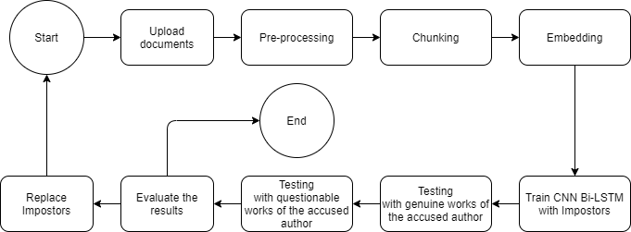

*Figure 1. Flow diagram of the training process*

## Data preprocessing and embedding

In this step, the input documents are being cleaned from unwanted noises such as numbers, dates, and special characters. NLTK is capable of preprocessing Russian words and texts and therefore, it is a good tool to have in the system.

With the aim to analyze short patterns of text, the system prepares tweets or chunks from the document. The tweets are basically a variable-length set of words from the text. To embed the refined text, the algorithm is using the ELMo embedding library, where each chunk is represented as a 2D vector of dimension where is the number of words in chunk and is the dimension of the embedding space.

## Data similarity measurements

The chunks are now represented as mathematically well-defined embeddings. A good impostors’ pair should be neither very similar nor too different. We measure the DTW distance between the two. The DTW distance is a good indicator for the quality of chosen impostors.

Measuring only the Euclidian distance will not work in cases where the time series are not the same length. When the series’ similar points are getting stretched farther away with time, their Euclidian distance is growing, and their similarities are missed.

Dynamic Time Warping distance algorithm works as follows:

1. Divide the two series and into equal points.
2. Time Warp - Get the minimum the Euclidian distance between and every.
3. Move to the second point and repeat Time Warping stage. Move step by step along points and repeat until all points are exhausted.
4. Repeat 2 and 3 but with the second series as a reference point.
5. Add up all the minimum distances that were stored and this is a true measure of similarity between the two series.

There are plenty of optimizations for the Dynamic Time Warping distance amongst them are Monotonicity, Continuity, etc., but reviewing the differences is out of the scope of this project.

## CNN

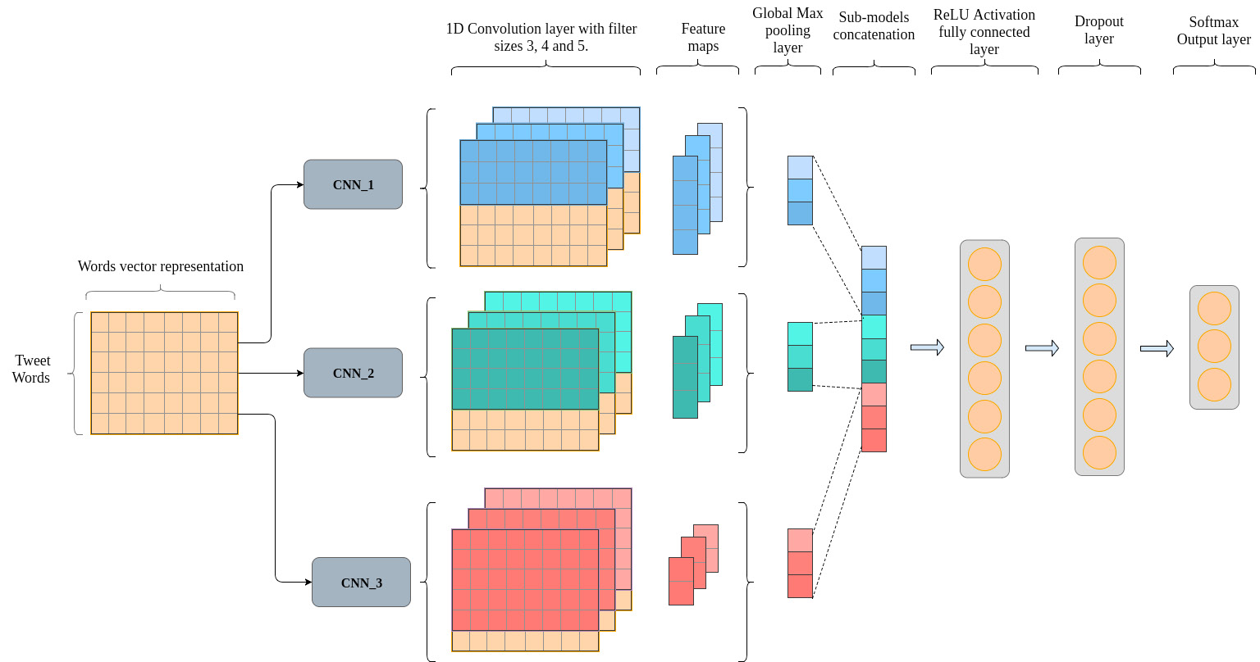

*Figure 2. CNN Architecture model*

The CNN model is built to distinguish between two authors’ writing styles. The model of [3] is followed. The input of the network is a matrix of “tweets”, which are tokenized into words. This model contains three parallel CNN sub-models where each of them has a certain filter size and filters. Feature maps received from each filter will be of size . Each sub-model has the same number of filters. Each output yields a vector of size .

Several convolution operations are applied to the matrix of chunks. The convolution involves a filtering matrix , where is the size of the convolution. The convolution operation is defined as:

* – Bias value
* – Nonlinear function (during this research, ReLU function)

Later then, a max-pooling is used and producing . This gets the most important feature for each . Also, it is applied to allow us to combine all the of each of the filters into a single vector. The vector is then passed through a small FC ReLU activation layer and then in turn through a soft-max layer to produce final probabilities of the classifications. After the max-pooling and the FC layers, an added dropout layer is intended to prevent overfitting.

## Bi-LSTM

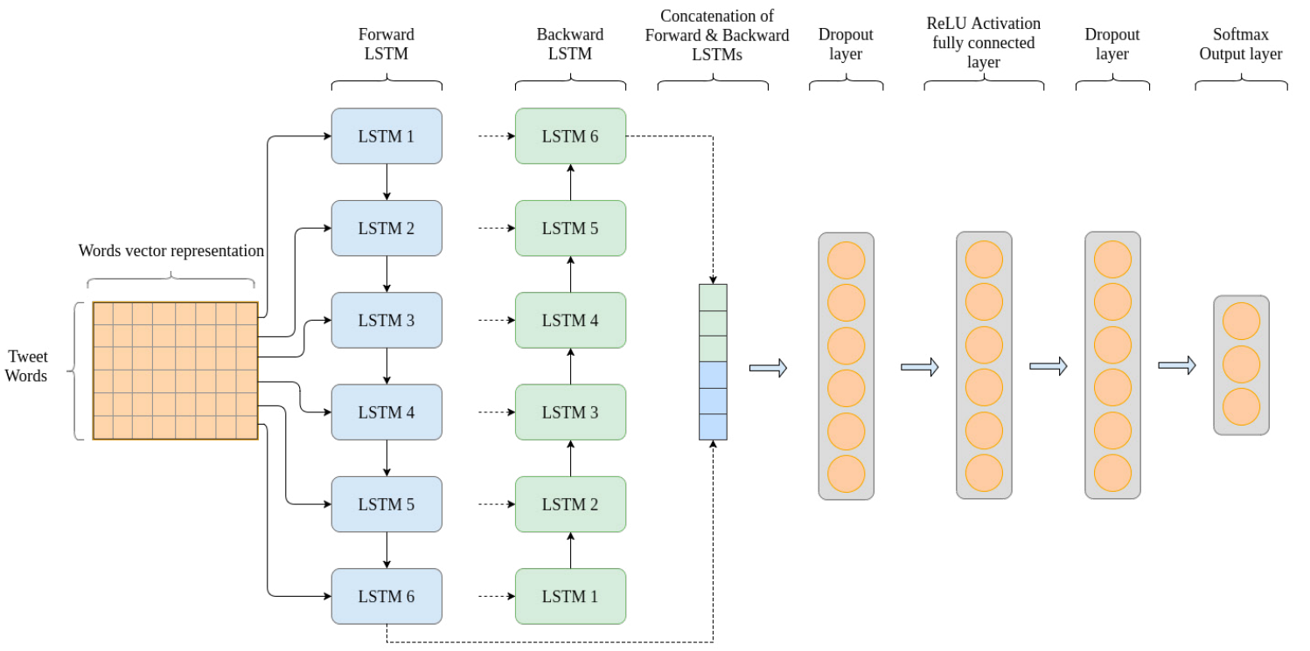

*Figure 3. LSTM Architecture model*

As an extended kind of RNN, LSTM is capable of learning long-term dependencies. The RNN hidden state value at a certain time is calculated as:

Where is the embedded word at the time t, and are weight matrices, is a bias value and is a non-linear function, usually . Due to the Vanishing Gradient problem, this simple RNN does not fit our task where predictions based on previous states are needed. LSTMs solve this problem and calculates its hidden state by:

The problem with LSTM is that it reads only in one direction. Thus, it does not consider post-word information well enough. Bi-LSTM, or two LSTMs with their outputs stacked together, is solving this matter excellently. Since there are two LSTMs instead of one, they can read forward and backward now. The chunks are passed to each layer of the LSTM, each LSTM is of size . The final output of each LSTM is concatenated to generate a vector of length . The concatenation output is fed to a FC ReLU activation layer, afterwards it is going through a soft-max layer. Lastly, an additional dropout layer is used in a similar way to the way it was in the CNN architecture. The dropout layers are places before the FC ReLU activation function and before the Soft-Max layer.

## Network Parameters

In these tables, the initial suggested parameters values of the system are shown. Using the developed GUI, these parameters may be changed in future use. Finding the best combination of parameters for the system is a complicated task but crucial to achieving optimal results. Promising results were observed using these parameters.

## CNN Component default parameters:

|  |  |
| --- | --- |
| Hyper-parameter | Value |
| Filter sizes | [3, 4, 5] |
| Number of filters | 200 |
| Number of units in fully connected layer | 30 |
| Dropout rate | 0.5 |
| Learning rate | 0.001 |
| Number of epochs | 10 |
| Batch size | 50 |

*Table 1. CNN default parameters*

## Bi-LSTM Component default parameters

|  |  |
| --- | --- |
| Hyper-parameter | Value |
| LSTM hidden state dimension | 200 |
| Number of units in fully connected layer | 30 |
| Dropout rate | 0.5 |
| Learning rate | 0.001 |
| Number of epochs | 10 |
| Batch size | 50 |

*Table 2. Bi-LSTM default parameters*

## Graphical User Interface

The prototype for a web-based dashboard built with the Streamlit library and Python. At the beginning of each experiment, the GUI allows uploading of all the required datasets and adjusting the parameters of the preprocessing phase and the neural network/LSTM parameters as well. Whenever Impostors datasets are uploaded, it shows a computed distance in the ‘Impostors’ proximity meter’. After the user presses the button “Start training”, it begins the training process and shows up all required information and plots to analyze the author's authorship.

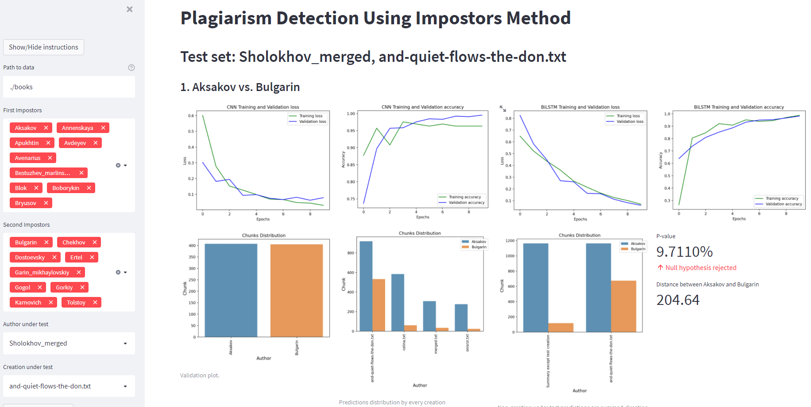

*Figure 4. GUI Overview*

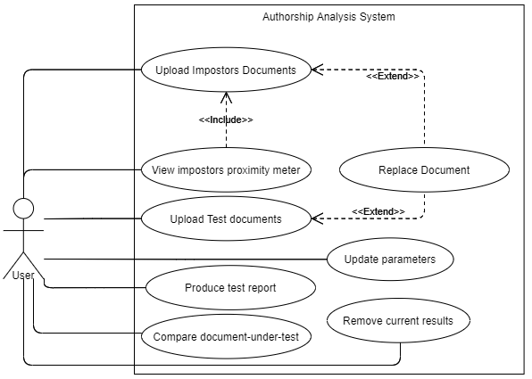

*Figure 6. Use case diagram of the GUI’s use case*

# Evaluation and Verification Plan

The best course of action for evaluating the system behavior would be the widely used “Black-Box Testing” approach alongside monitoring the algorithms' loss and Accuracy values. Cover testing is the most acceptable form of development of test cases, practiced by industries and researchers worldwide. Thus, the “Cover testing” principles are being applied and used in this research as the main form of the system evaluation. Previously tested and accepted tools are used to build the system, and they will not be tested again, for example the preprocessing or embedding frameworks, assuming they are functioning correctly. ELMo embeds, and CNN classifies, and there is no need to make sure of it. The need is to make sure that the classification and other predefined tasks are being solved accurately. Thanks to the “Impostors’ proximity meter,” avoiding underfitting is possible; this aspect should not be checked.

In table 3, test cases for possible combinations of the impostors' datasets and the system expected behavior regarding the “Impostors’ proximity meter” functionality. Table 4 presents Black-Box tests of possible classifications of the questionable literature under the assumption that the system is previously fed with an appropriate pair of the impostors and the assumption and tested with genuine works. Finally, GUI testing is presented in table 5 and is validating the proper functioning of most of the GUI operations by presenting operations available for the user and the required outcome of them, done by the system.

|  |  |  |
| --- | --- | --- |
| **Test Case** | **Input** | **Expected Result** |
| Case A | Two impostors with similar writing style | Impostors’ proximity meter displays good feedback. |
| Case B | Two impostors of different times/different genre | Impostors’ proximity meter displays bad feedback. |
| Case C | The two impostors set both consist of the same author different works | Impostors’ proximity meter displays great feedback |

*Table 3. Expected distance computations of impostors*

|  |  |  |
| --- | --- | --- |
| **Test Case** | **Input** | **Expected Result** |
| Case A | A genuine work of the accused author | Classified the same as most of the other works with high accuracy rate |
| Case B | Plagiarism – A work that has been written by an author different then the accused | Classified as either of the classes regardless of the genuine work’s classifications |
| Case C | A partially plagiarized text – A work that was written by the accused author and by another as well | Classified the same as most of the other works with low probability |

*Table 4. Expected predictions for model inputs*

|  |  |  |
| --- | --- | --- |
| **Test Case** | **Event** | **Expected Result** |
| Case A | No datasets have been uploaded or only one and the user clicked “start” | GUI displays Error:  “Please enter the three required datasets” |
| Case B | Three datasets had been uploaded and the user clicked “start” | GUI displays the “Impostors’ proximity meter”, starts training and append results to dashboard |

*Table 5. Uploading datasets*

An excellent text suited for the evaluation of the system would be “And Quiet Flows the Don” as the literature under-test alongside unquestionable kinds of literature of Sholokhov. It is to be remembered that most researchers around this novel supported Sholokhov from a mathematical perspective. Therefore, another document is gathered to execute the test cases in an unbiased manner properly.

# Appendices

## User Guide

The “Plagiarism Detection Application” is a web-based application built on Streamlit and was designed for smooth operation and pleasant experience.

Its purpose is to let researchers, that are interested in using the impostors’ method in the field of authorship analysis and plagiarism detection specifically, to put their assumption and suspicions under a test. With the system, researchers can analyze results and obtain performances of the method in solving the task. With the GUI, changing the parameters and visualizing the results was never easier. Researchers can use the system to obtain predictions and prove innocence of their loved authors.

We deliver this application undeployed, and therefore, using it requires configuring the environment, which might be complex, but we made it as easy as possible. In order to run the application, please follow next steps:

1. Confirm that you have latest Anaconda installed, and clean Python 3.9 environment (configured with Anaconda) is available
2. From the root folder of the project, using any CLI, activate the environment and run:
   1. “setup.bat” under Windows only
   2. “pip3 install -r requirements.txt”
   3. “python ./setup.py install”

This will do most of the work.

1. If all the packages were installed successfully, you will be able to run the application using “streamlit run app.py” from the same CLI
2. In the output, you will see the address where the application is available, by default it is <http://localhost:8501>, but the port could be different.

As you access the main page, you will be able to experiment for the name of science, please follow the next steps to understand how to operate the system:

1. Open the sidebar if it is not already opened (Arrow at the top left of the screen)
2. Direct the system to the data by providing a full path to the data location. The data location is expected to be a folder, containing sub-folders, one for each author. The sub-folders should contain creations of the authors with “.txt” extensions.
3. Choose the required impostors by their names for the experiment, we allow multiple choices, i.e., when you choose 2 authors for First Impostors and 2 authors for Second Impostors, they will be paired according to the order you chose them.
4. Choose the “Author under test” and “Creation under test” written by him. Please note that for the algorithm proper functioning, the questionable author should have more than one creation in his folder.
5. Before you run the experiment, on the bottom of the sidebar, you can see the Neural Network hyperparameters, which could be tuned to receive more accurate results.
6. Now you will be able to run “Analyze Authorship” and wait for the results.
7. After a while, you will see the results as bar-plots and our approximate prediction, makes you easier to analyze the authorship of “Creation under test”

## Maintenance Guide

## Class Diagram

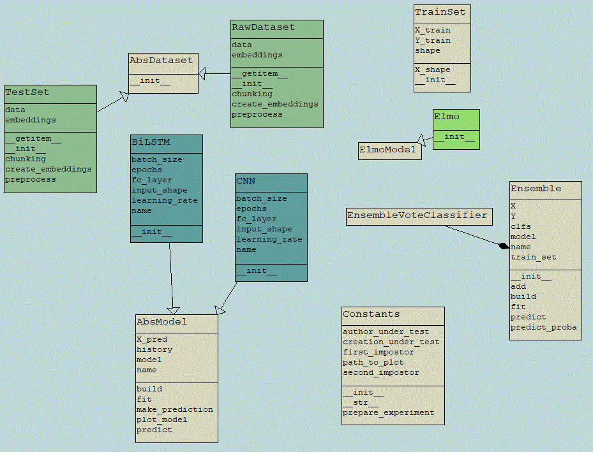

## Environment Description

As written is in “User’s Guide” first, we must install our environment. Since we use Streamlit for the GUI our main script is “app.py”. Most of the project are written using classes and only GUI and Utility methods were written separately.

In the “requirements.txt”, we may see all external packages which were used for the project. Sometimes, there are dependency issues, and app is terminating, often the restart solves it.

# References

* 1. el Mostafa, Hambi & Benabbou, Faouzia. (2020). A deep learning-based technique for plagiarism detection: a comparative study. IAES International Journal of Artificial Intelligence (IJ-AI). 9. 81. 10.11591/ijai.v9.i1.pp81-90.
  2. Volkovich, Zeev. (2020). A Short-Patterning of the Texts Attributed to Al Ghazali: A “Twitter Look” at the Problem. Mathematics. 8. 10.3390/math8111937.
  3. Heikal, Maha & Torki, Marwan & El-Makky, Nagwa. (2018). Sentiment Analysis of Arabic Tweets using Deep Learning. Procedia Computer Science. 142. 114-122. 10.1016/j.procs.2018.10.466.
  4. Kim, Yoon. (2014). Convolutional Neural Networks for Sentence Classification. Proceedings of the 2014 Conference on Empirical Methods in Natural Language Processing. 10.3115/v1/D14-1181.
  5. Cliche, Mathieu. (2017). BB_twtr at SemEval-2017 Task 4: Twitter Sentiment Analysis with CNNs and LSTMs. 573-580. 10.18653/v1/S17-2094
  6. Sepp Hochreiter and Jürgen Schmidhuber. 1997. Long Short-Term Memory. Neural Comput. 9, 8 (November 15, 1997), 1735–1780. DOI:https://doi.org/10.1162/neco.1997.9.8.1735.
  7. Koppel, Moshe & Winter, Yaron. (2014). Determining If Two Documents Are Written by the Same Author. Journal of the Association for Information Science and Technology. 65. 10.1002/asi.22954.
  8. D. R. Baymurzina, D. P. Kuznetsov, and M. S. Burtsev, ‘‘Language model embeddings improve sentiment analysis in Russian,’’ in Proc. Int. Conf. Dialogue Comput. Linguistics Intell. Technol., vol. 18, 2019, pp. 53–63.